Parkietenbos Field Work Report

Names: Deandra Arends

Sharilusca Thomas

Crisleidy Lopez de la Cruz

            Stephany Wong

Date: November 6 2017

Course: Environmental Science

* **Make sure all your data is typed into in a google or excel spreadsheet.**

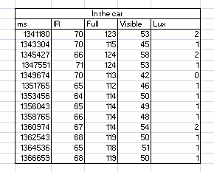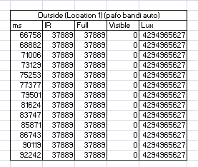

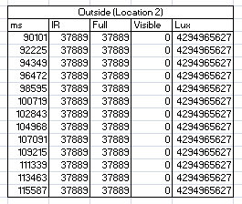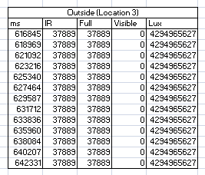

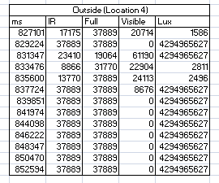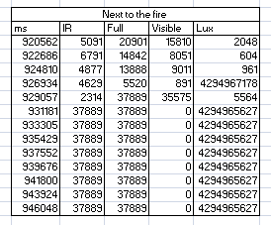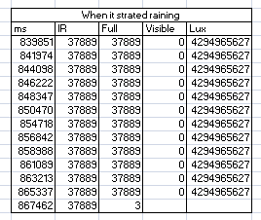

* **Calculate average measurements for each location (there should be several at the dump and several at the school, e.g. next to a burning pile, close to the trucks, in the courtyard, etc.).**

**In the car**

|  |  |  |  |  |
| --- | --- | --- | --- | --- |
| Ms | IR | Full | Visible | Lux |
| 17601877 ÷13=  1,353,990.90 | 875 ÷13=  67.31 | 1523 ÷13=  117.15 | 649 ÷13=  49.92 | 16 ÷13=  1.15 |

**Outside (Location1) ( pafo bandi auto)**

|  |  |  |  |  |
| --- | --- | --- | --- | --- |
| Ms | IR | Full | Visible | Lux |
| 1,032,252 ÷13=  79,404 | 492,557 ÷13=  37,889 | 492,557 ÷13=  37,889 | 0 | 5,583,455315 ÷13=  5.583455315 |

**Outside ( Location 2)**

|  |  |  |  |  |
| --- | --- | --- | --- | --- |
| Ms | IR | Full | Visible | Lux |
| 1232,96.7 ÷13=  94343.62 | 37,889 | 37,889 | 0 | 5.583455315 ÷13=  429496562.70 |

**Outside ( Location 3)**

|  |  |  |  |  |
| --- | --- | --- | --- | --- |
| Ms | IR | Full | Visible | Lux |
| 818,4643 ÷13=  619,587.92 | 37,889 | 37,889 | 0 | 429496562.70 |

**Outside ( Location 4)**

|  |  |  |  |  |
| --- | --- | --- | --- | --- |
| Ms | IR | Full | Visible | Lux |
| 10,918,028÷13=839,848.31 | 404,222 ÷13=  31,094 | 467,613 ÷13=  35970.23 | 137,597 ÷13=  10,584.38 | 4294972520÷13=330382501.50 |

**Next to the fire**

|  |  |  |  |  |
| --- | --- | --- | --- | --- |
| Ms | IR | Full | Visible | Lux |
| 12,132,964 ÷13=  933,304.92 | 288,925 ÷13=  22,225 | 358263 ÷13=  27,553.69 | 69338 ÷13=  5333.69 | 3.43597466÷13=26,430,574.30 |

**When it started raining**

|  |  |  |  |  |
| --- | --- | --- | --- | --- |
| Ms | IR | Full | Visible | Lux |
| 11,098,611÷13=8133,739.31 | 37,889 | 454,671 ÷13=  34,974.69 | 0 | 429496562.70 |

* **Discuss the observations you made while taking measurements.**

What we could notice was that before leaving the car the MS was 7 numbers, the IR of 2 numbers, Full of 3 numbers, Visible of 2 numbers and Lux ​​of 1 number. However, when we left, the Ms low to 5 numbers and the rest went up, but not visible, visible was then 0 for a good time, most of the times. When we moved to other places it remain at 0, it was very few times that it showed a numeral.

* **Discuss your findings:**
  + **What do your numbers indicate?**

The  numbers measured by the sensor indicate that while it is in full range of the sun the amount infrared radiation (IR) remains consistent throughout the duration of the experiment. The amount of lumens (Lux) also remains the same. This means that the amount of  infrared radiation and the amount of lumens do not fluctuate in a given situation. They remain consistent under the given environments and do not change unless the environment changes. Under specific varied situations the lumens will become visible in low amounts but are most of the time invisible to the naked eye. As seen in the given excel-sheet, the numbers change in different locations. By a fire for example, the amount of lumens change because the smoke covers the sun and so do some of the clouds when it rained which is why the amount of lumens go down.

* + **How do your numbers compare in the context of the international standards / normal levels?**

Lumen numbers and infrared radiation is very varied around the world. In international standards they tend to change constantly and especially in big countries. This is usually caused by external factors such as Mist, Fog, Hurricanes, Rainfall, and much more. This means that Aruba has an exceptionally consistent luminescence, and infrared radiation which is one of the causalities for substantial heat in Aruba.